.
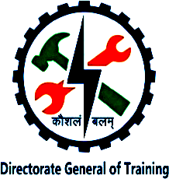

NATIONAL SKILL TRAINING INSTITUTE (NSTI) KOLKATA, DASNAGAR, HOWRAH

LESSON PLAN
NAME: Ankita singh TRADE/ROLL NO.: CSA /1420

UNIT/LESSON NO. 12 DATE & TIME : 23/10/2025
- PREPARATION

TITLE/TOPIC: TCP (Transmission Control Protocol)

OBJECTIVES: At the end of the lesson trainee shall able to -
a) Able to TCP.
b) Describe the features and working of TCP.
c) Key Features of TCP

TEACHING AIDS : WHITE BOARD,MARKER,PROJECTOR,PPT,PENDRIVE, ETC.
INTRODUCTION:
REVIEW/LINK/MOTIVATION:-
- HTTP / HTTPS (Web Browsing)
- FTP (File Transfer)
- SMTP (Email)
- Telnet / SSH (Remote Login)

PRESENTATION :
OBJECTIVES | INFORMATION POINTS | SPOT HINTS
TCP  Definition | TCP (Transmission Control Protocol) is one of the main protocols of the Transport Layer in the TCP/IP model.  Definition  TCP is a connection-oriented protocol that ensures reliable communication between devices over a network. It divides data into packets, sends them, and makes sure they arrive correctly and in order. | 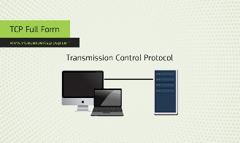

OBJECTIVES | INFORMATION POINTS | SPOT HINTS
Key Features of TCP  Working of TCP | Key Features of TCP:  - Connection-Oriented:  A connection is established before data transfer (like a phone call).  - Reliable Data Transfer:  Ensures all data reaches the destination without loss or duplication.  - Error Checking:  Uses checksums to detect errors in data.  - Acknowledgment (ACK):  Receiver sends an acknowledgment when data is received.  - Flow Control:  Prevents sender from overwhelming the receiver with too much data.  - Ordered Delivery:  Packets arrive in the same order they were sent.  - Congestion Control:  Adjusts data transmission rate when the network is busy.  Working of TCP  - Connection Establishment:  Uses a three-way handshake:  - SYN → SYN-ACK → ACK  - Data Transfer:  Data is sent in segments, acknowledged by the receiver.  - Connection Termination:  Uses a four-step handshake to close the connection safely. | 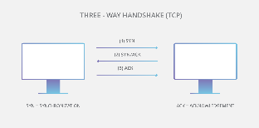  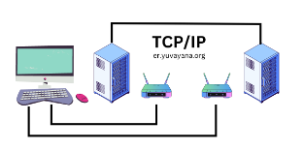
- APPLICATION :
a) What do you understand by TCP.
b) Explain the features and working of TCP.

SUMMARY : To repeat the objectives/main points once again.
Repeat the 2nd step in short
- TEST/QUESTIONS :
a) What is TCP?
b) What are the main features of TCP?
c) Give examples of applications that use TCP.

ASSIGNMENT:
- Define what TCP is and explain its purpose.
- Describe the features and working of TCP

Reference: Copa Book, Online

NEXT LESSON: Telnet

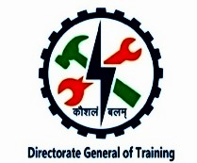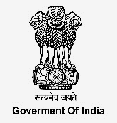

NATIONAL SKILL TRAINING INSTITUTE (NSTI) KOLKATA, DASNAGAR, HOWRAH

INFORMATION SHEET

TITLE/TOPIC: TCP

INFORMATION: TCP (Transmission Control Protocol) is one of the main protocols of the Transport Layer in the TCP/IP model.
Definition
TCP is a connection-oriented protocol that ensures reliable communication between devices over a network. It divides data into packets, sends them, and makes sure they arrive correctly and in order.

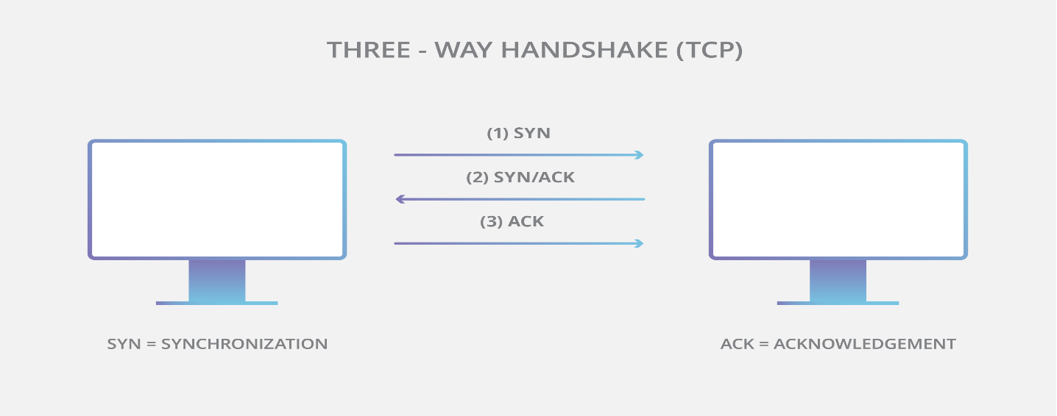

Key Features of TCP:
- Connection-Oriented:
A connection is established before data transfer (like a phone call).
- Reliable Data Transfer:
Ensures all data reaches the destination without loss or duplication.
- Error Checking:
Uses checksums to detect errors in data.
- Acknowledgment (ACK):
Receiver sends an acknowledgment when data is received.
- Flow Control:
Prevents sender from overwhelming the receiver with too much data.
- Ordered Delivery:
Packets arrive in the same order they were sent.
- Congestion Control:
Adjusts data transmission rate when the network is busy.

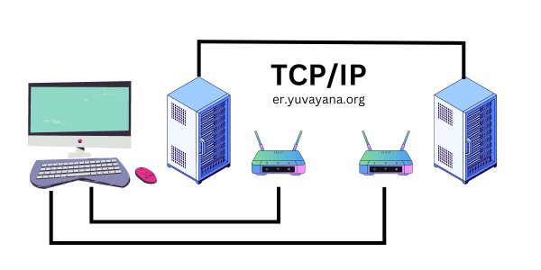

Working of TCP
- Connection Establishment:
Uses a three-way handshake:
  - SYN → SYN-ACK → ACK
- Data Transfer:
Data is sent in segments, acknowledged by the receiver.
- Connection Termination:
Uses a four-step handshake to close the connection safely.

